pandas program

Aim
To create a Pandas DataFrame from a dictionary and display the data, information about data types and non-null values, and statistical summary.
Algorithm
- Import the Pandas library as pd.
- Create a dictionary containing Name, Age, and City details.
- Convert the dictionary into a DataFrame using pd.DataFrame().
- Display the first five rows using df.head().
- Display column information and data types using df.info().
- Display the statistical summary using df.describe().
- Stop the program.
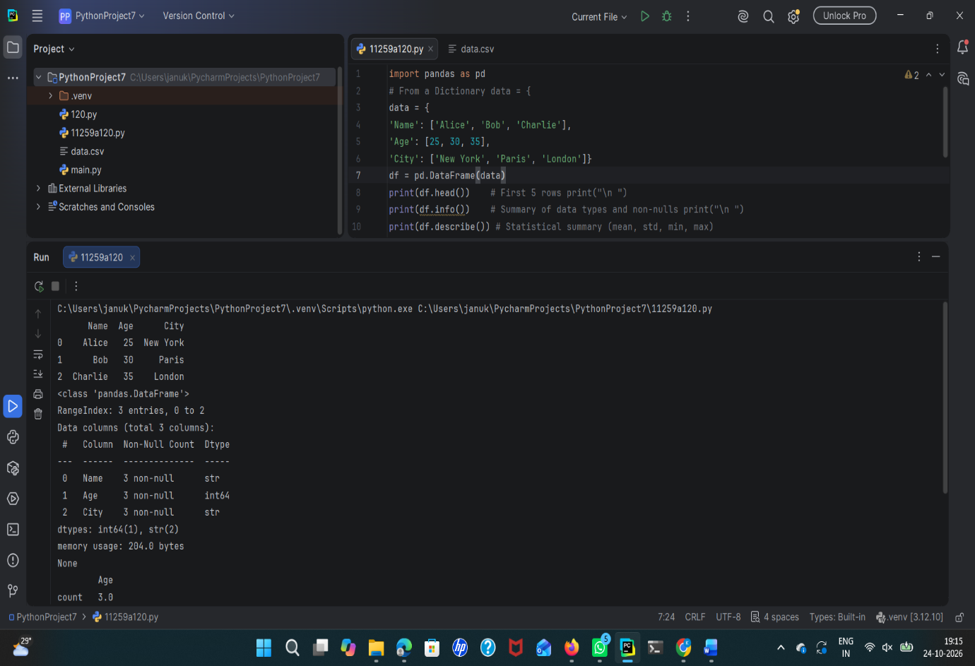
Result
Thus, the Pandas DataFrame was created successfully, and the program displayed the data, column information, data types, and statistical summary.

Aim
To perform selection and filtering operations on a Pandas DataFrame using column selection, conditional filtering, iloc[], and loc[].
Algorithm
- Start the program.
- Import the Pandas library.
- Create a DataFrame containing the person's name, age, and city.
- Select the Age column from the DataFrame.
- Filter the rows where the age is greater than 25.
- Use iloc[0] to display the first row by index position.
- Use loc[0, 'Name'] to select the name of the person at index 0.
- Display all the results.
- Stop the program.

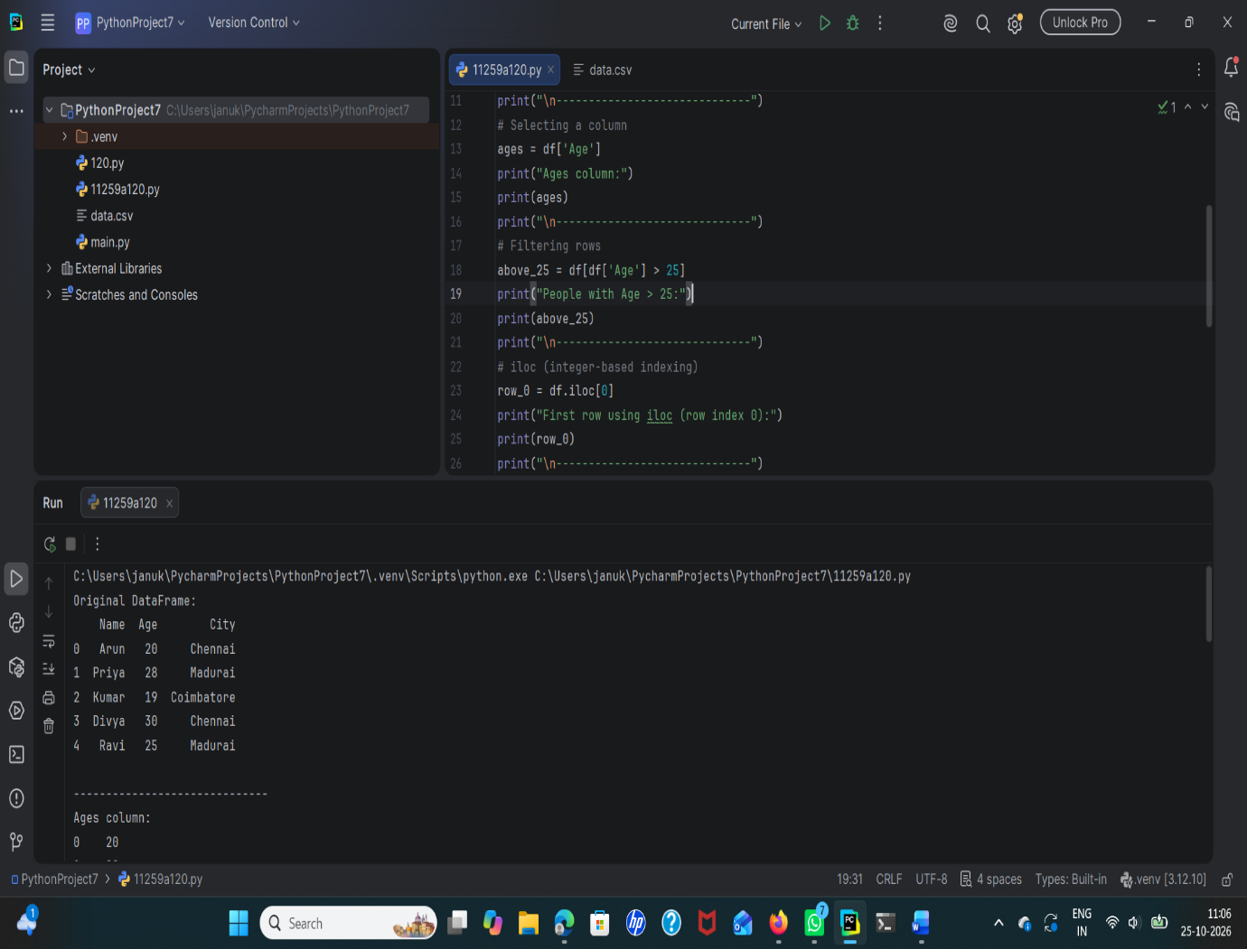
Result
Thus, the selection and filtering operations on a Pandas DataFrame were successfully performed using column selection, conditional filtering, iloc[], and loc[].

Aim
To perform data cleaning in Python using the Pandas library by identifying and handling missing values in a DataFrame using dropna(), fillna(0), mean imputation, and filling missing city names with "Unknown".
Algorithm
- Start the program.
- Import the Pandas and NumPy libraries.
- Create a sample dataset containing missing values (NaN) in the Age and City columns.
- Convert the dataset into a Pandas DataFrame.
- Display the original DataFrame.
- Identify and count missing values in each column using isnull().sum().
- Remove rows containing missing values using dropna().
- Fill all missing values with 0 using fillna(0).
- Calculate the mean of the Age column and fill missing Age values with the mean.
- Fill missing City values with "Unknown".
- Display the cleaned DataFrames.
- Stop the program.

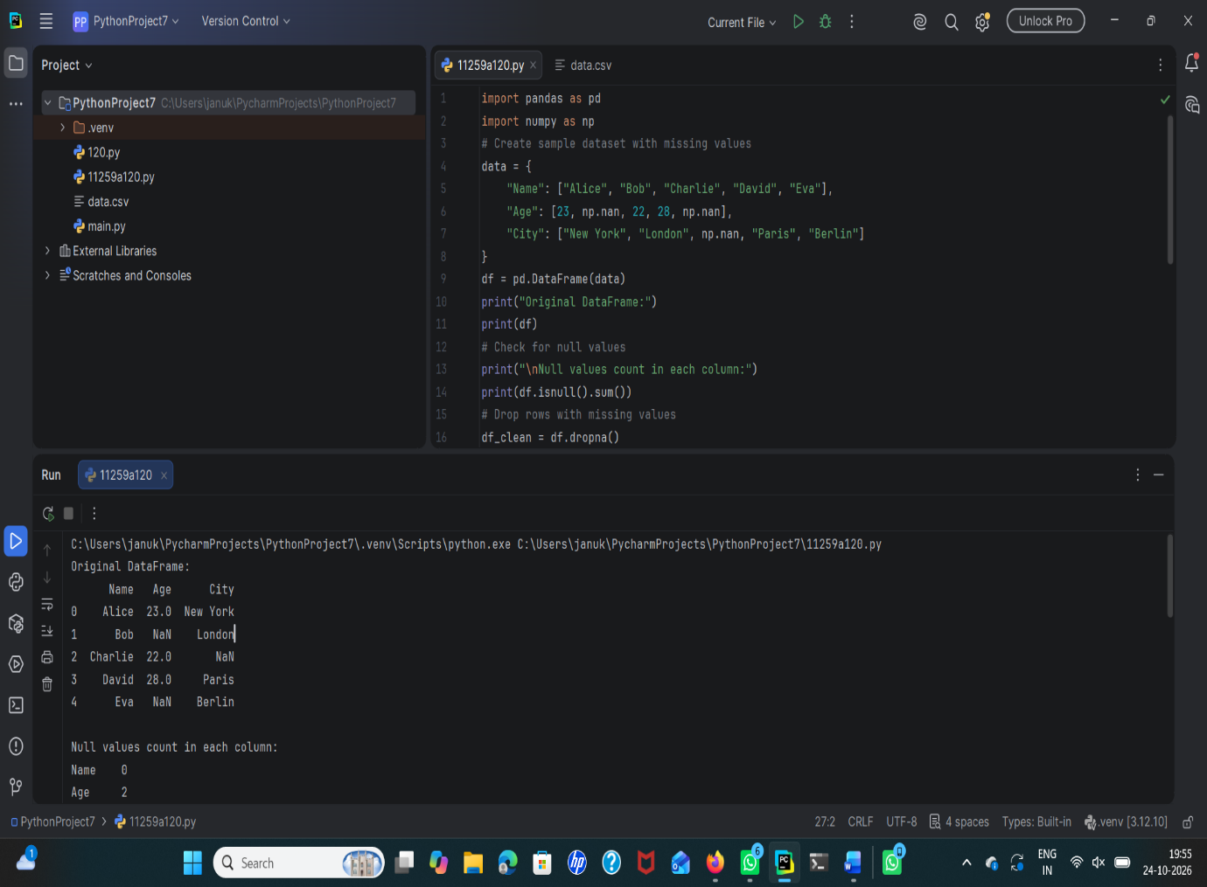
result
Thus, the data-cleaning program was executed to identify and handle missing values in a DataFrame using row deletion, zero replacement, mean imputation, and replacement with "Unknown".

